Sponsorship Opportunities

2022
Courage Ranch

Courage Ranch
3292 Highway 97 West
Floresville, Texas 78114
832-721-3874

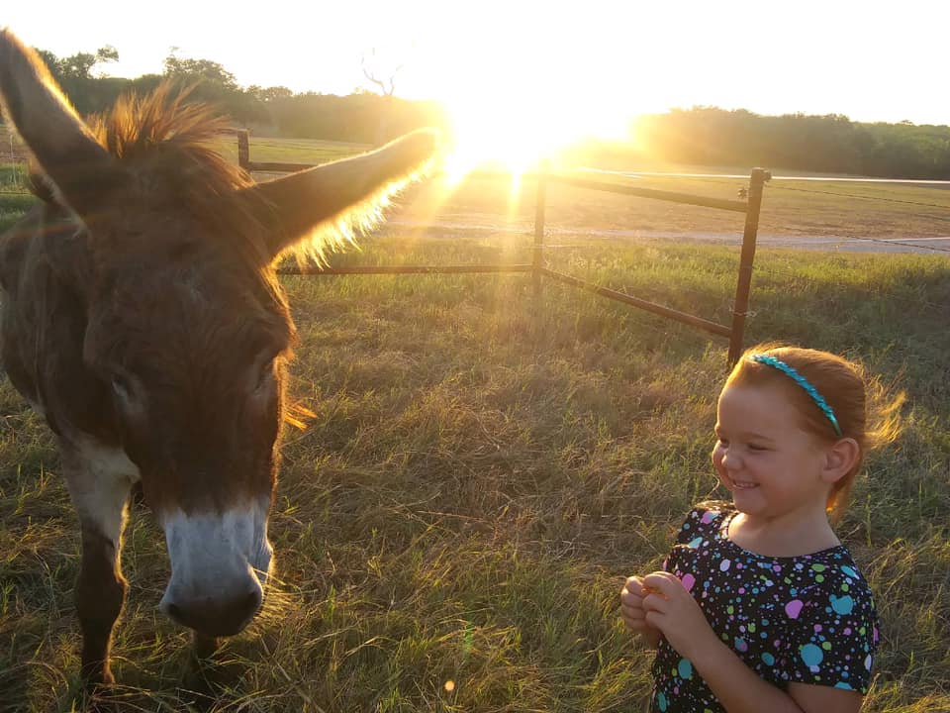
Dear Partner:

Courage Ranch is a trauma-focused equine assisted psychotherapy program located in Floresville, Wilson County, Texas. Courage Ranch provides mental health services for a rural area of South Texas (Atascosa, Karnes, and Wilson Counties), where mental health support is very limited. Wilson County and the surrounding rural communities have needed mental health support services for many years; however, tragically it took the State’s largest mass shooting to date at the First Baptist Church in Sutherland Springs (located 14 miles from our facility) in 2017 to put a spotlight on this issue. According to the County Health Rankings, Atascosa, Karnes, and Wilson Counties currently have a mental health provider to patient ratio of 1:2,450, 1:4,480, and 1:7,590, respectively; whereas, the State of Texas has a ratio of 1:960, and the top performers in the U.S has a ratio of 1:310. Realizing the lack of mental health providers and programs available in rural South Texas, the Courage Ranch co-founders have made it their mission to provide mental health support to a traditionally underserved, rural population by providing programing specifically focused on trauma using equine assisted psychotherapy. In fact, the specific need for equine psychotherapy in this rural community was so abundant that after only two short weeks of accepting clients in February 2019, the facility was at client capacity.
Our unique program utilizes knowledge of trauma, brain development, and the way trauma impacts an individual’s worldview and functioning in relationships. The mental health professional/horse partnership provides a safe space for clients to learn how to self-regulate. Although using equine-assisted psychotherapy is not a traditional approach to helping those in need of mental health services, it has been proven to be a highly effective way to provide mental health services. Since most of a horse's communication is through their body, it is acutely attuned to a client's body movements. This attunement brings awareness to clients' repeated somatic expression and affective states that may currently be out of their own awareness. Courage Ranch provides individual and group sessions for children and adults. Both programs pair licensed mental health providers (LPC) with horses and clients. All therapy programs include principles from the Natural Lifemanship TF-EAP model, which is based on the neuroscience of brain development and several other treatment modalities. Courage Ranch offers and combines multiple evidence-based principles and approaches in treatment plans because services are client specific, meaning each client receives an individual treatment plan.
Courage Ranch is a newly incorporated non-profit organization. We are seeking financial partners who are interested in supporting our mission of providing mental health support to rural South Texas. This organization remains committed to our community by providing hope and healing to so many deserving people. Please visit our website at www.courageranch.org to learn more about our mission, vision, philosophy regarding equine assisted therapy and opportunities for giving. Your assistance would bridge the gap between our present and future funding as we move into 2021.
Thank you in advance for considering Courage Ranch as a recipient of your giving.

Sincerely,

Leann Drozd
Executive director
Investment Opportunities

PLATINUM SPONSOR $10,000(+)
- Named on Courage Ranch website donor page
- Your logo included on Courage Ranch website footer
- Weekly advertisement on Courage Ranch Facebook
- Recognition on various print marketing materials
- Announced as sponsor at all events
GOLD SPONSOR $5,000 - $9,999
- Named on Courage Ranch website donor page
- Recognition on various print marketing materials
- Bi-monthly advertisement on Courage Ranch Facebook
- Announced as sponsor at all events

SILVER SPONSOR $1,000 - $4,999
- Named on Courage Ranch website donor page
- Recognition on various print marketing materials
- Monthly advertisement on Courage Ranch Facebook
- Announced as sponsor at all events

BRONZE SPONSOR $100 - $999
- Named on Courage Ranch website donor page
- Announced as sponsor at all events

FRIENDS OF COURAGE RANCH $25.00 or $50.00 monthly by EFT/PayPal
- Gift of Courage Ranch t-shirt and koozie
- Will be entered to win quarterly drawings for prizes. $25 Members receive 1 entry; $50 Members receive 2 entries for each month active

Yes, I will be a PLATINUM level sponsor for $10,000(+)

Yes, I will be a GOLD level sponsor for $5,000 - $9,999

Yes, I will be a SILVER level sponsor for $1,000 - $4,999

Yes, I will be a BRONZE level sponsor for $100 - $999

Yes, I will be a FRIEND of COURAGE RANCH for $25 or $50 per month

THIS PAGE IS TO BE INCLUDED with YOUR PAYMENT
INVESTMENT agreement

We look forward to the partnership. Please make checks payable and mail Along with Page 3 & 4 to:
courage ranch
Attn: Leann Drozd
3292 Hwy 97 W
Floresville, Texas 78114

Sponsor Information:

Business Name: ___________________________________________

Primary Contact: _________________________________________

Address ________________________________________________

Phone: _________________________________________________

Email: __________________________________________________

Amount Paid: ___________________ Check Number: ___________
Credit Card Number: ____________________________________
Card Type:____________ Billing Zip Code:__________
Expires: ____________ Security Code: ______________
Name on Card: _________________________________________
Signature: ____________________________________________

SPECIAL INSTRUCTIONS: ______________________________________________________________________

THIS PAGE IS TO BE INCLUDED WITH YOUR PAYMENT.

